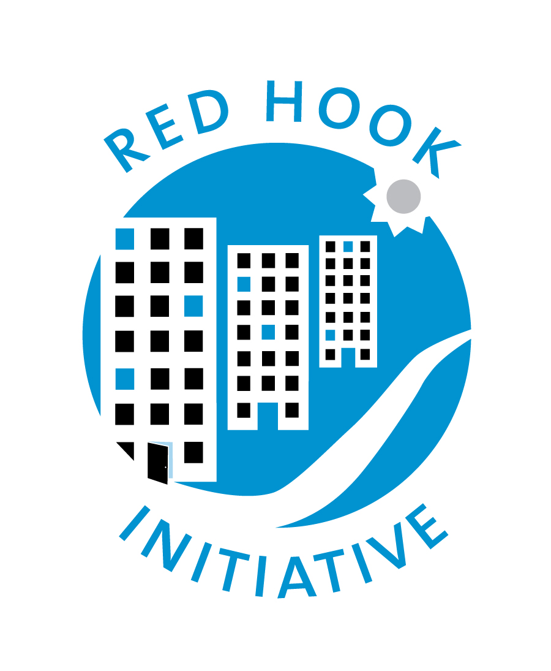
Job Description
Environmental Justice Fellow
Reports To: Environmental Justice Manager Employment Status: Part time
FLSA Status: Non- Exempt
Compensation: $20/hr

ABOUT RED HOOK INITIATIVE (RHI)
Red Hook Initiative (RHI) is a community-based nonprofit working to improve the lives of the more than 6,500 residents of Red Hook Houses, Brooklyn’s largest public housing complex. RHI believes that the social change to overcome systemic inequities begins with empowered youth, and that change in communities should come from within. In partnership with community adults, we nurture young people in Red Hook to be inspired, resilient, and healthy, and to envision themselves as co-creators of their lives, community, and society.

Youth development, community building, and community hiring are at the core of RHI’s approach to strengthen Red Hook’s future. Our model gives young people and residents the tools, resources, and opportunities they need to interrupt the systems and barriers that perpetuate historic inequities for the community. Residents lead the way toward a more equitable, hopeful future. Over our 20-year history, RHI’s model and dedicated team have been nationally recognized for its innovative, place-based approach to social change.

RHI’s programs include:
- Youth Development: RHI engages over 350 adolescents each year, from middle school through young adulthood, endeavoring to interrupt cycles of injustice and to build hope.
- Building Community: Working with Red Hook youth and adults to organize, exercise leadership to drive positive change for the community, and increase social cohesion to build a more resilient neighborhood.
- Investing in Residents: RHI hires locally and invests in residents who will improve their lives and the community in which they live. More than $1.5M was earned in the last year by people from Red Hook.
- Red Hook Farms: A youth-centered urban agriculture and food justice program operating one of Brooklyn’s original and largest farms. Red Hook Farms cultivates affordable, fresh produce and provides STEM and nutrition education, leadership development, and employment opportunities for local youth and residents.

RHI creates a culture of excellence with our ten core values as the foundation: community leadership, mutual respect, welcoming space, strengths-based perspective, trust, high expectations, encouragement, inspiration, holistic approach and adaptability.

JOB SUMMARY
The Environmental Justice Fellow will work to build leadership skills and literacy around environmental science and environmental justice in Red Hook through RHI’s newly launched air monitoring initiative. The Organizer will train with our partners at CUNY’s Advanced Science Research Center, honing their skills in environmental science, data analysis and environmental justice organizing in Red Hook, and then bring those skills back to the Red Hook Community. The Fellow will work as part of RHI’s Community Building Team to monitor the air, share information about air quality with the Red Hook community, and support RHI’s campaigns relating to public housing and the expansion of last-mile warehouses.

ESSENTIAL DUTIES + RESPONSIBILITIES

Training & Youth Development
- Participate in trainings with the Advanced Science Research Center lab at City University of New York, developing skills in electronics & circuitry, coding and environmental science (this training takes place in Harlem)
- Provide weekly reflection to supervisor throughout training period
- Participate in additional trainings and conferences related to RHI’s work
- Work with the Environmental Justice Manager to implement youth development programming including a Freedom Schools cohort and workshops for RHI youth

Air Monitoring
- Work with the Environmental Justice Manager to install and manage static monitors in the Red Hook community
- Work with partners to develop a data sharing platform to communicate air quality issues with the Red Hook community

Community Outreach
- Attend community meetings in Red Hook to gather information and updates on issues impacting the community and to share information about RHI’s work
- Support the EJ Manager in developing a Community Advisory Council and facilitating Council meetings
- Mobilize Red Hook residents to participate in community organizing campaigns through strategies such as door knocking, tabling, and street outreach

Additional Responsibilities:
- Participate in weekly Community Building Team meetings and monthly RHI All Staff meetings
- Support record keeping and reporting requirements

COMPETENCIES (Knowledge, Skills & Personal Attributes)
- An outgoing personality with a desire to interact with peers and neighbors
- A passion for the environment, arts & sciences and the community of Red Hook
- Interest in design, coding and data collection
- Knowledge of Google Drive and Gmail, Microsoft Word
- Experience working in an education or after-school setting
- Experience living and/or organizing in public housing communities
- Ability and willingness to work in person
- Willing to travel to Harlem three times a week for training portion (July - August)

SKILLS YOU WILL DEVELOP
- Basic circuit design and principles of electronics, soldering and electrical metrology Basic programming and debugging (Arduino IDE, C, C++, java)
- Internet networking and Internet-of-Things
- Experimental Design; Rapid Prototyping and 3D Printing
- Data analysis and visualization

WORKING CONDITIONS (ENVIRONMENT) & PHYSICAL DEMANDS
- The RHI work environment is characteristic of a typical indoor office/program environment and the noise level is generally quiet to moderate.
- While performing the essential duties and responsibilities of the job the employee will be required to operate a computer and other office equipment. The employee can sit or stand at will.
- RHI provides a hybrid work arrangement for employees, when possible. In this role, a hybrid schedule can be arranged when direct services are not in session. We currently require all staff to be in the office for a minimum of 3 days per week, subject to changes in COVID-19 rates. Hybrid schedules can be accommodated.
- This job is based on-site at RHI’s main program office in Red Hook, Brooklyn. The ideal candidate will either be a resident of Red Hook or one of its neighboring communities or will be within reasonable commuting distance to RHI’s main program office.

COMMITMENT TO DEI & EQUAL EMPLOYMENT OPPORTUNITY
RHI actively engages individuals from all backgrounds and is committed to embracing diversity across all areas and aspects of the organization. We firmly believe that an atmosphere of civility and mutual respect towards individual differences and embracing an inclusive and equitable environment is indispensable to building a successful organization, contributing to a positive and meaningful employment experience for staff, and advancing the best possible outcomes for the clients served by RHI’s programs. We are also committed to community hiring and supporting the job prospects of Red Hook residents.
As an equal opportunity employer, RHI is committed to providing employment opportunities to all qualified individuals and does not discriminate against any employee or applicant on the basis of race, color, national origin, religion, sex, sexual orientation, gender, gender identity and expression, disability, age, marital status, military status, veteran status, pregnancy, parental status, genetic information, or any other characteristic or basis prohibited by applicable law.
RHI requires that all staff be fully vaccinated with an FDA authorized vaccine. RHI abides by New York State requirements and acknowledges those may change over time. If moved forward to the screening process, you will have a chance to ask the interviewer more about this requirement

To Apply please complete this form

Date Issued: March 13, 2024

